**Lakukan performance test pada url** [**https://reqres.in/api/users?page=2**](https://reqres.in/api/users?page=2) **dengan ketentuan:**

● Number of Threads: 100

● Loop Count: 10

● Ramp-Up Period: 100 Lalu, jelaskan hasilnya berdasarkan data reporting yang didapat, reporting dapat meliputi graph dan table.

**1. Thread Group**

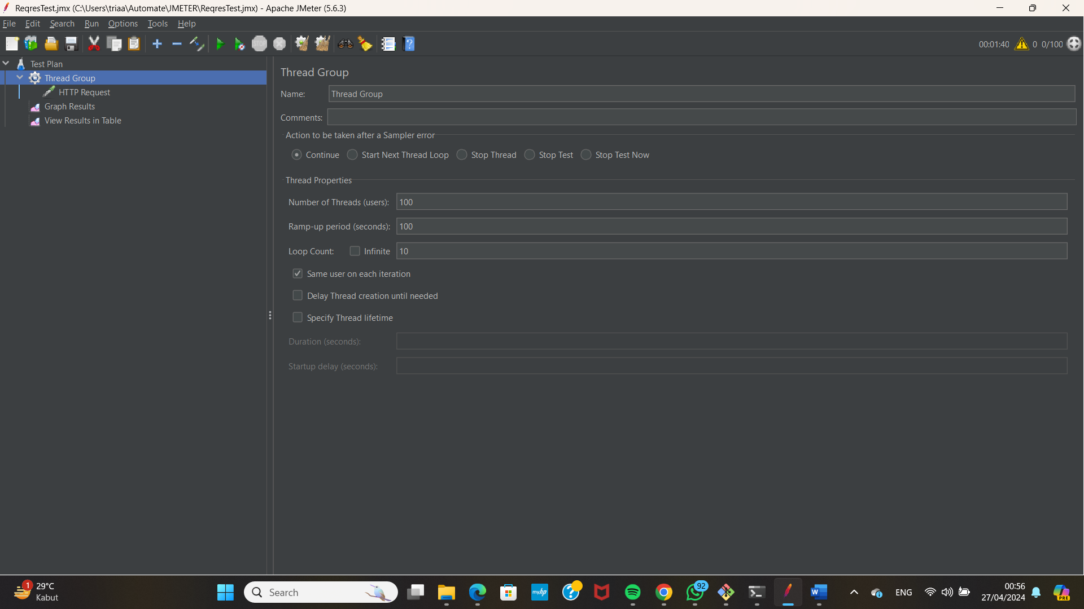

**2. Http Request**

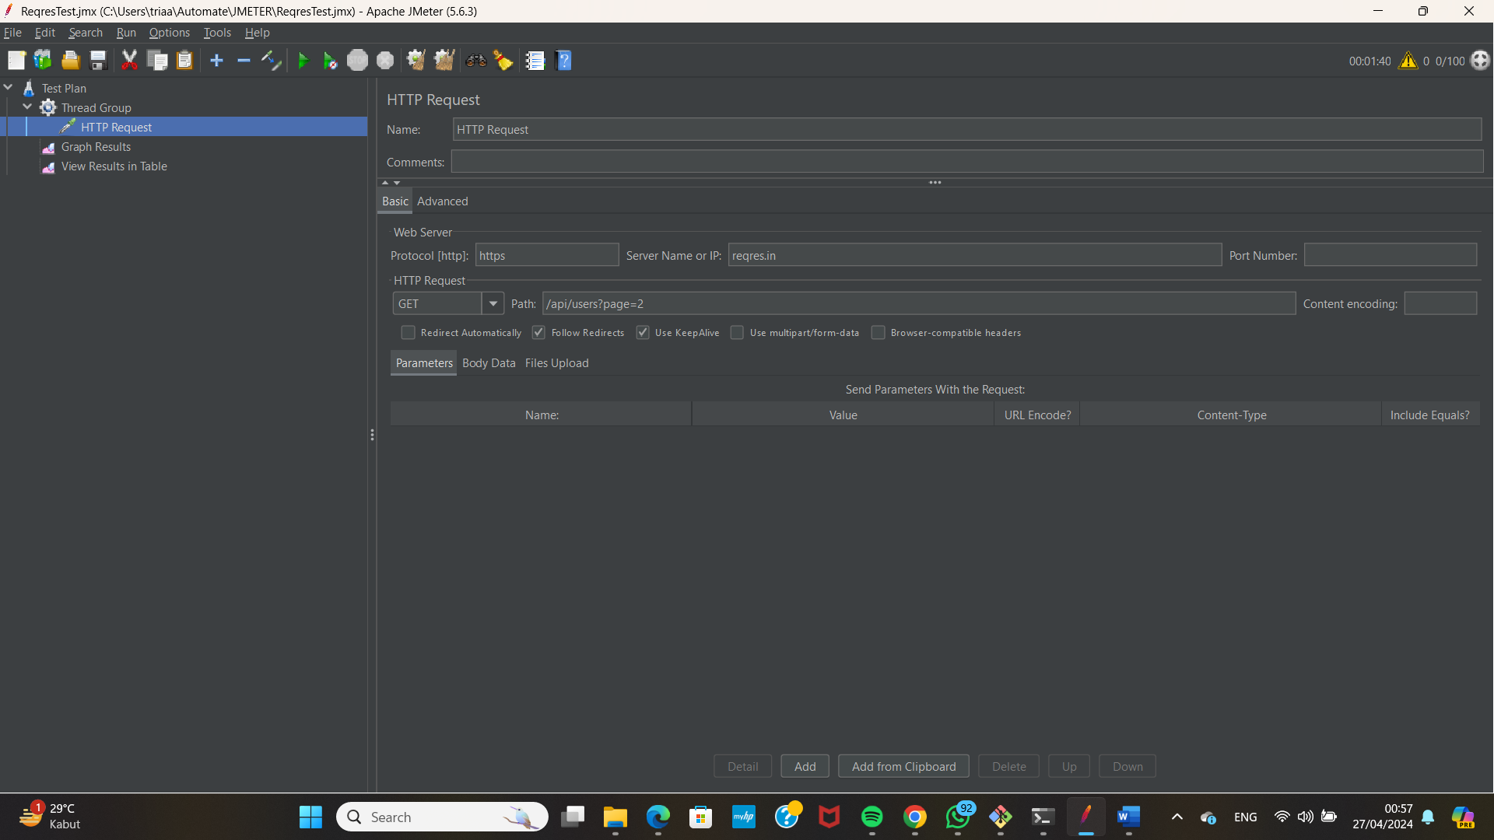

**3. Graph Result**

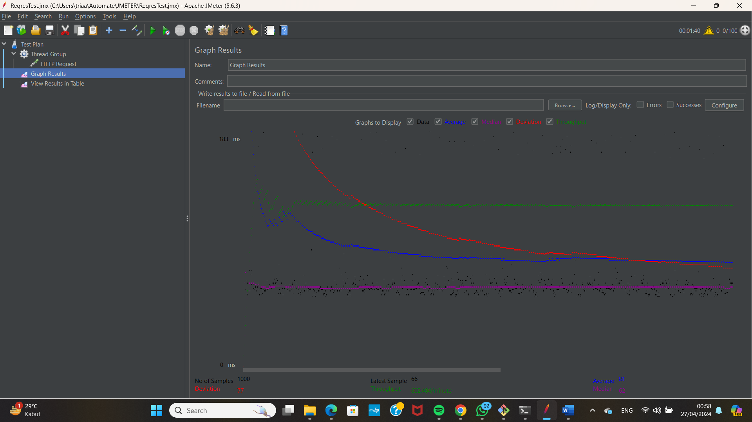

**4. View Results Table**

